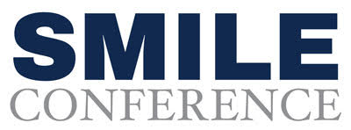
[Insert Date]

Dear Chief,
I respectfully request approval to attend the SMILE Conference in Orlando, Florida, from October 21–23, 2026. This nationally recognized conference is the premier training event for law enforcement professionals focused on social media, digital engagement, and modern communication strategies.
SMILE goes well beyond theory. The conference delivers three days of hands-on training designed specifically for law enforcement, covering community engagement, event promotion, crisis communication, recruitment, and investigative uses of social media. The sessions are practical, current, and immediately applicable to our daily operations.
Attending SMILE would strengthen my ability to communicate effectively with the public, increase transparency, and support our agency’s mission using proven and responsible digital tools. The knowledge gained would directly benefit our department and our community.
The conference features top experts in the industry who specialize in law enforcement communication, digital strategy, and investigative social media. They’ll be sharing practical tools, fresh ideas, and proven techniques that can directly strengthen our agency’s online presence and community outreach.
Attending will also give me the opportunity to connect with professionals from across the country and around the world, allowing me to learn from their experiences and bring back new perspectives. I will share all key takeaways with our team so the entire department benefits from the training.
At the conclusion of the conference, I will earn a certificate, adding to my professional development and supporting our agency’s commitment to ongoing training and excellence.
Here are the registration costs:

Registration Period | SMILE | Virtual Smile
Now – August 15th, 2026 | $699 | $499
August 16th - October 21st, 2026 | $799 | $450

I believe attending the SMILE conference will be a great investment for our department, and I hope you’ll approve my request.

Thank you for considering this.
Sincerely,
[Your Name]

